10.35: a) 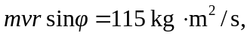 with a direction from the right hand rule of into the page.

b) out of the page.

